

22-24 Elgin Chambers, Cemetery Road, Shelton, Stoke-on-Trent, ST4 2DL
Tel: 01782 890121
Email: office@emergeschool.co.uk
www.emergeschool.co.uk

Friday 26th September 2024
Dear Parents/Guardians,
RE: Indoor Rock Climbing Experience
I hope this message finds you well. I am excited to inform you that Maple class will be embarking on a special trip to the YMCA Hanley to participate in a rock climbing experience. This event is scheduled for Tuesday 8th October 2024, and it promises to be both educational and enjoyable for our students.
The rock climbing activity aligns closely with our current topic work in PHSE, Science, and PE. It will provide students with a unique opportunity to develop their physical skills, build teamwork and resilience, and gain insights into the principles of physics that apply to climbing. We believe that these experiences will greatly enrich their learning and foster a sense of accomplishment.
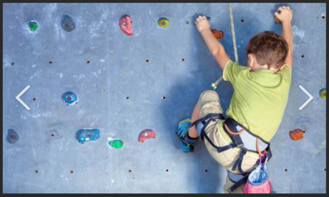
Details of Trip:
Date: Tuesday 8th October 2024
Time: 9.30am to 11.30pm
Location: YMCA Hanley
Please ensure your child comes dressed in school PE kit, and trainers. Please send your Childs water bottle with them. We will be back at school in time for our normal school lunch.
The class will walk to the YMCA together, this will take approximately 10 minutes and will help the students to improve their road safety awareness, and ability to take directions.
To confirm your child's participation, please complete the consent form overleaf and return it to us as soon as possible.
We appreciate your continued support and enthusiasm for our learning activities. If you have any questions or concerns, please feel free to reach out.
Best regards,



Head of Education: Mrs. Clowes Deputy Head/ SEN Lead: Miss Laing

22-24 Elgin Chambers, Cemetery Road, Shelton, Stoke-on-Trent, ST4 2DL
Tel: 01782 890121
Email: office@emergeschool.co.uk
www.emergeschool.co.uk

I give permission for my child, to participate in the school trip To the YMCA on Tuesday 8th October 2024. I understand that normal school times still apply, and I will ensure that my child adheres to all school rules and expectations during the trip.

Name of child: _______________________________________

Parent/Guardian Signature: ______________________________________________

Contact Number:

