
Embrace Mindful Empathic Recovery Growth Empower

‘Learning Today for a Better Tomorrow’

22-24 Elgin Chambers, Cemetery Road, Shelton, Stoke-on-Trent, ST4 2DL
Tel: 01782 890121
Email: office@emergeschool.co.uk
www.emergeschool.co.uk

Tuesday 8th October 2024
Dear Parents and Carers,
We are delighted to announce an exciting opportunity for our Emerge students. On Tuesday, 15th October, students from Blossom, Chestnut, Willow, and Birch classes will embark on a memorable trip to Wheelock Farm for a fun-filled day of pumpkin picking. This excursion not only promises a delightful selection of pumpkins but also aims to enrich our students' outdoor learning experiences.
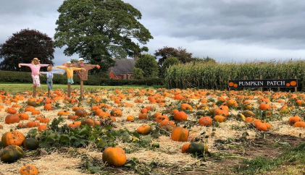
Where: Wheelock Farm
When: Tuesday 15th October

At Wheelock Farm, students will have the unique chance to choose their own pumpkins, which they will later bring back to school for a creative carving session in class. This activity will allow students to express their artistic talents while also integrating lessons about the seasonal changes and agricultural practices associated with autumn.
In addition to pumpkin picking, the students will have the opportunity to interact with various farm animals, further enhancing their understanding of wildlife and farming. To complement the educational aspect of the trip, there will also be time allocated for play in the park, ensuring that the day is not only informative but also enjoyable.
Transportation to Wheelock Farm will be provided via the school mini-bus. We kindly request that you ensure your child brings their booster seat to school on the day of the trip if they usually require one for travel. To support the costs associated with this enriching outing, we are asking for a modest donation of £5 per student. This contribution will assist in covering transportation and other expenses associated with the trip. We kindly ask that you return the attached permission slip, along with your donation, to the school no later than Monday, 14th October.
We appreciate your cooperation and support in making this experience possible for our Emerge students. It promises to be a day filled with learning, laughter, and unforgettable memories. Should you have any questions or need further information, please do not hesitate to contact us.
Thank you for your continued support.
Warm regards,


Head of Education: Mrs. Clowes Deputy Head/ SEN Lead: Miss Laing

22-24 Elgin Chambers, Cemetery Road, Shelton, Stoke-on-Trent, ST4 2DL
Tel: 01782 890121
Email: office@emergeschool.co.uk
www.emergeschool.co.uk

I give permission for my child, to participate in the school trip Wheelock Farm on Tuesday 16th October 2024. I understand that normal school times still apply, and I will ensure that my child adheres to all school rules and expectations during the trip.

Name of child: _______________________________________

Parent/Guardian Signature: ______________________________________________

Contact Number:

The students will have lunch at the farm, if you would like school to provide a packed lunch for your child please chose below:

Ham Sandwich Cheese Sandwich

