
Embrace Mindful Empathic Recovery Growth Empower

‘Learning Today for a Better Tomorrow’

22-24 Elgin Chambers, Cemetery Road, Shelton, Stoke-on-Trent, ST4 2DL
Tel: 01782 890121
Email: office@emergeschool.co.uk
www.emergeschool.co.uk

Tuesday 8th October 2024
Dear Parents and Carers,
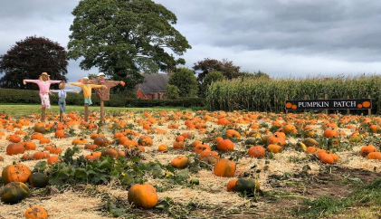
We are delighted to announce an exciting opportunity for our Emerge students. On Tuesday, 22nd October, students from Sycamore, Oak and Maple classes will embark on a memorable trip to Canalside Farm for a fun-filled day of pumpkin picking. This excursion not only promises a delightful selection of pumpkins but also aims to enrich our students' outdoor learning experiences.

Where: Canalside Farm
When: Tuesday 22nd October

At Canalside Farm, students will have the unique chance to choose their own pumpkins, which they will later bring back to school for a creative carving session in class. This activity will allow students to express their artistic talents while also integrating lessons about the seasonal changes and agricultural practices associated with autumn.
In addition to pumpkin picking, the students will have the opportunity take part in the spooky maze and other Halloween activities at the farm.
Transportation to Canalside Farm will be provided via the school mini-bus. To support the costs associated with this enriching outing, we are asking for a modest donation of £5 per student. This contribution will assist in covering transportation and other expenses associated with the trip. We kindly ask that you return the attached permission slip, along with your donation, to the school no later than Monday 21st October.
We appreciate your cooperation and support in making this experience possible for our Emerge students. It promises to be a day filled with learning, laughter, and unforgettable memories. Should you have any questions or need further information, please do not hesitate to contact us.
Thank you for your continued support.
Warm regards,


Head of Education: Mrs. Clowes Deputy Head/ SEN Lead: Miss Laing

22-24 Elgin Chambers, Cemetery Road, Shelton, Stoke-on-Trent, ST4 2DL
Tel: 01782 890121
Email: office@emergeschool.co.uk
www.emergeschool.co.uk

I give permission for my child, to participate in the school trip to Canalside farm on Tuesday 22nd October 2024. I understand that normal school times still apply, and I will ensure that my child adheres to all school rules and expectations during the trip.

Name of child: _______________________________________

Parent/Guardian Signature: ______________________________________________

Contact Number:

The students will have lunch at the farm, if you would like school to provide a packed lunch for your child please chose below:

Ham Sandwich Cheese Sandwich

