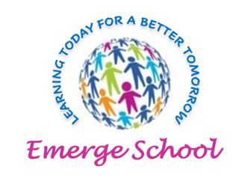
Embrace Mindful Empathic Recovery Growth Empower

‘Learning Today for a Better Tomorrow’

22-24 Elgin Chambers, Cemetery Road, Shelton, Stoke-on-Trent, ST4 2DL
Tel: 01782 890121
Email: office@emergeschool.co.uk
www.emergeschool.co.uk

Tuesday 15th October 2024
Dear Parents/Guardians,
Re: Trip to Trentham Monkey Forest

I hope this letter finds you well. I am writing to inform you about an upcoming school trip that we are organising as part of our Jungle Book topic. We are thrilled to announce that we will be visiting the Trentham Monkey Forest!
Date: 23/10/2024
Time: Departure 9.30 Return Time: 14:00
Location: Trentham Monkey Forest
The purpose of this trip is to enhance our understanding of jungle habitats and animal behaviour. Observing these fascinating creatures in their natural habitat will provide invaluable insights into their communication, eating habits, and movements.
Transport to, and from the Monkey Forest will be provided using our own school minibus.
To give consent for your child to join this exciting trip please fill in the slip attached and return it to school by Monday 21st October. Students should come to school dressed in PE clothing a waterproof coat and shoes suitable for walking in. The class will be having lunch at the Monkey Forest you can send in a packed lunch for your child or we can provide one if you choose the option on the slip/
We assure you that this trip will be a well organised, supervised and conducted in terms with our school’s policies and guidelines. As parents we understand you may have concerns or questions regarding this outing, please don’t hesitate to get in touch and we will provide all the necessary information to alleviate any worries you may have. Your child’s safety and wellbeing are of paramount importance and every precaution will be taken to ensure a secure and enjoyable experience for all children and staff.
Kindest Regards,

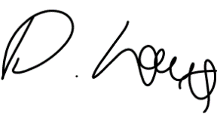

Head of Education: Mrs. Clowes Deputy Head/ SEN Lead: Miss Laing

22-24 Elgin Chambers, Cemetery Road, Shelton, Stoke-on-Trent, ST4 2DL
Tel: 01782 890121
Email: office@emergeschool.co.uk
www.emergeschool.co.uk

I give permission for my child, to participate in the school trip to Trentham Monkey Forest on Wednesday 23th October. I understand that normal school times still apply, and I will ensure that my child adheres to all school rules and expectations during the trip.

Name of child: ________________________________________________

Parent/Guardian Signature: ______________________________________

Contact Number

We will be having lunch at the Monkey Forest, if your child normally brings a packed lunch to school this can be taken with them, alternatively school can provide a packed lunch.

If you would prefer a school packed lunch please tick here and select from the options below.
Ham sandwich Cheese Sandwich

