
Embrace Mindful Empathic Recovery Growth Empower

‘Learning Today for a Better Tomorrow’

22-24 Elgin Chambers, Cemetery Road, Shelton, Stoke-on-Trent, ST4 2DL
Tel: 01782 890121
Email: office@emergeschool.co.uk
www.emergeschool.co.uk

Thursday 7th November 2024
Subject: Exciting Trip Announcement for Maple and Sycamore Classes
Dear Parents and Guardians,
I hope this message finds you well. I am pleased to inform you about an upcoming trip for the Maple and Sycamore classes on Wednesday, 13th November. We will be visiting the Apedale Heritage Centre to explore the history of industry in Stoke-on-Trent, featuring a guided tour of an underground coal mine and the informative museum at the site. We will also enjoy the beautiful surroundings of Apedale Community Country Park where we will have a picnic lunch.
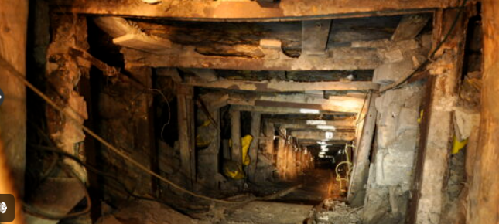
When : Wednesday 14th November
Where: Apedale Heritage Centre
Times : 09.30 – 14.30

We will use the school minibus for transportation, and to help cover entry and travel costs, we kindly request a donation of £5. Please complete the attached permission slip, indicating whether you will provide a packed lunch or if you would like the school to provide one.
We advise that students wear warm clothing, waterproof coats, and sensible shoes
Rest assured, the trip will adhere to all safety policies and guidelines. Should you have any questions, please feel free to reach out.
Thank you for your Continued support.



Head of Education: Mrs. Clowes Deputy Head/ SEN Lead: Miss Laing

22-24 Elgin Chambers, Cemetery Road, Shelton, Stoke-on-Trent, ST4 2DL
Tel: 01782 890121
Email: office@emergeschool.co.uk
www.emergeschool.co.uk

I give permission for my child, to participate in the school trip to Apedale Heritage Centre on Wednesday 13th November. I understand that normal school times still apply, and I will ensure that my child adheres to all school rules and expectations during the trip.

Name of child: _______________________________________

Parent/Guardian Signature: ______________________________________________

Contact Number:

I will provide a packed lunch on the day.

I would like a school packed lunch on the day.

Ham Cheese

